1. **Log in to the Azure Portal**:
   * Go to the [Azure Portal](https://portal.azure.com) and sign in with your account.
2. **Create a New Virtual Machine Scale Set**:
   * Click on **"Create a resource"** from the left-hand menu.
3. **Configure the Basics**:
   * **Subscription**: Choose your subscription.
   * **Resource Group**: Either create a new resource group or select an existing one.
   * **Scale Set Name**: Provide a name for your scale set.
   * **Region**: Select your desired region (e.g., West US).
   * **Availability Zone**: Choose whether to use availability zones or not.
   * **Image**: Select **"Ubuntu"** from the list of available images (choose the specific version you need, e.g., Ubuntu 20.04 LTS).
   * **Instance Count**: Set the **Initial Instance Count** to **1**.
4. **Configure Scaling Options**:
   * Go to the **"Scaling"** tab.
   * **Minimum number of VMs**: Set this to **1**.
   * **Maximum number of VMs**: Set this to **5**.

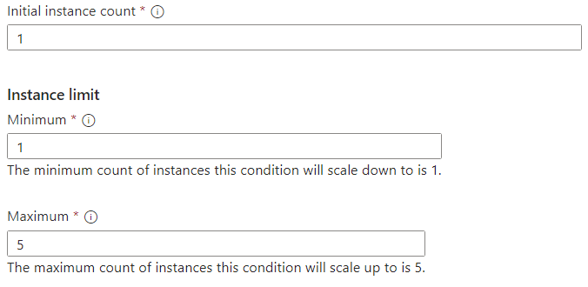

**Step 2: Configure Autoscale Settings**

1. **Set Autoscale Rules**:
   * In the scaling section, you will define scaling rules based on CPU utilization.
   * Set the **scale-out rule** to trigger when the **CPU percentage** exceeds **75%**.
     + - **Condition**: CPU Percentage > 75%
       - **Action**: Increase by **1 VM**

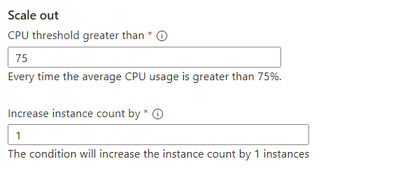

* + Set the **scale-in rule** to trigger when the **CPU percentage** drops below **25%**.
    - * **Condition**: CPU Percentage < 25%
      * **Action**: Decrease by **1 VM**

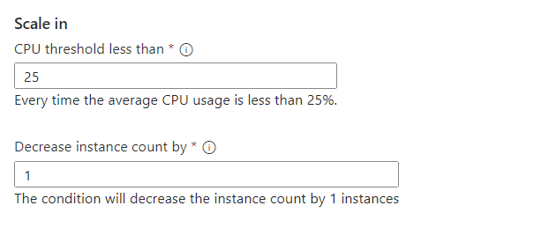

* + Cooldown period: (set a cooldown period as per your needs, e.g., 5 minutes)

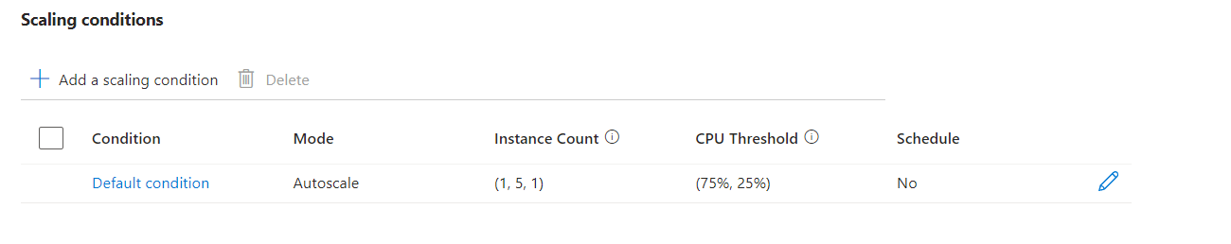

**Step 3: Configure Networking and Review**

1. **Networking Settings**:
   * Click on **"Next: Networking"** to configure network settings.
   * Choose a new or existing virtual network and subnet.
2. **Review + Create**:
   * Review all configurations.
   * Click **"Create"** to provision the VM scale set. This may take a few minutes.

